1. Source Code

* Controller 🡪 Matakuliah.php
* Views 🡪 view-form-matakuliah.php

1. URL :

http://localhost:8888/ci_hadi/index.php/matakuliah

1. 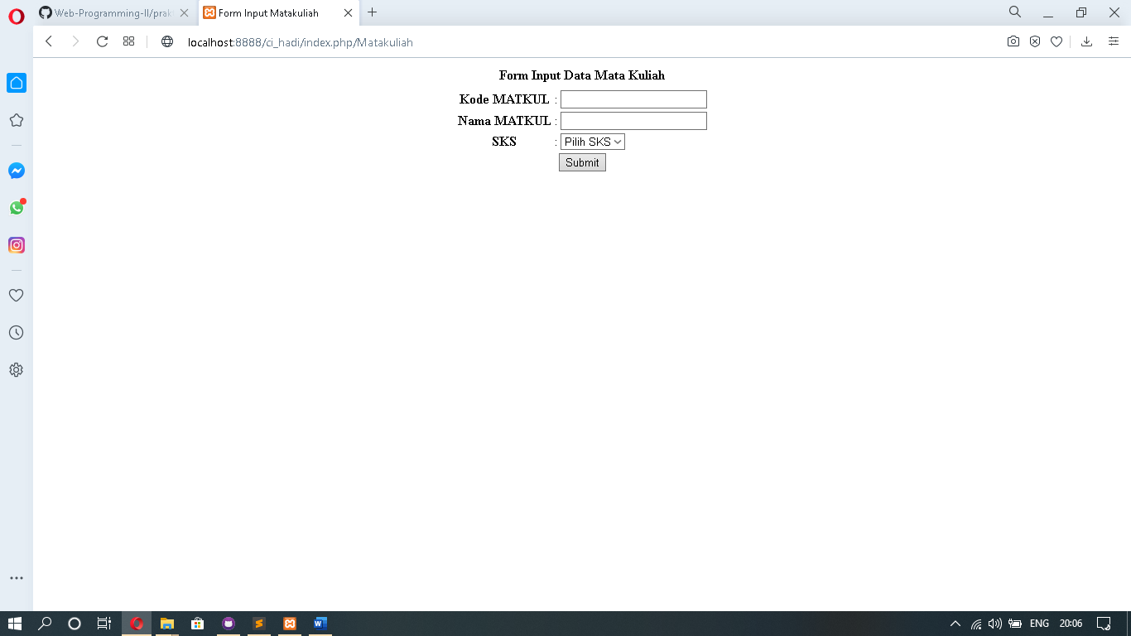Screen Shoot